

**UNIVERSITY OF PETROLEUM AND ENERGY STUDIES**

**School of Computer** **Science**

**2020-21**

**GRAPHICS AND ANIMATION TOOLS LAB**

**Faculty: Dr. DURGANSH SHARMA**

**Assistant Professor**

**Department of Cybernetics.**

**School of Computer Science, UPES**

**Submitted By:**

**Name - Vartika Deep**

**Course - B.Tech CSE(OS&OS)**

**SAP ID - 500062441**

**Semester - VII**

**Batch - B3**

**Roll no. - R100217088**

**VIVA 2**

**1.Create any Mountain Range with Snowfall over it using GIMP.**

**STEPS:**

1.Go to file-new-ok.

2.Select paintbrush tool and hardness.

3.Draw a mountain and color it black.

4.Select smudge tool and use it on the image to give the effect of mountain.

5.Select paintbrush tool and select blue color and paint tip of the mountain.

and then select white color to color other parts.

6.Selct smudge tool and use it to apply it on the image to give the effect of the mountain

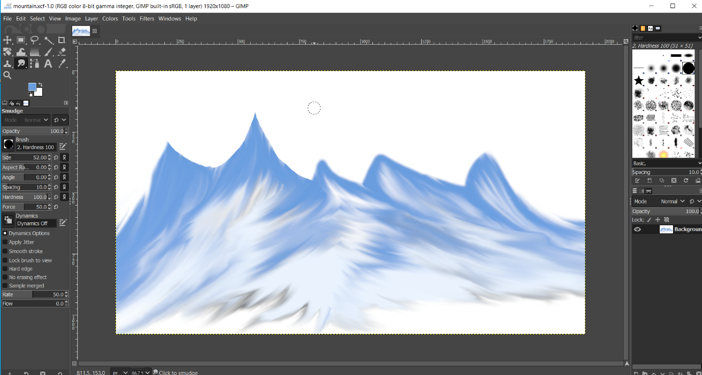

**2. Create any City or Skyscraper using Blender**

**CITY**

**STEPS:**

1.Add plane.

2.Add two plane to make roads in the city.

3.Select loop cuts to create windows and rooms.

4.Select upper faces to make the roof.

5.Duplicate the buildings to create a city.

